Guide to Countdown

Video guide can be found here:
https://www.youtube.com/watch?v=OW06tCX9yLo

Last Updated : Y2024 - M07 - D7

Countdown
Countdown is a gamemode centered around the Pentco nuclear station, it is 8 man content based around completing certain objectives and extracting within a time limit.
It is very good for farming gear and weapons, as it drops a ton of loot each run, and because of the time limit you know that at most you will spend 19 minutes in a run. And each run you will be facing one of the game's 6 main factions.

You can matchmake for it from the map or from one of the pilots, challenging and heroic countdown is very popular so you will likely get into a group quickly.
Countdown and Summit both allow you to select your Targeted Loot, allowing you to farm for what you are after much more easily.

This guide will expand on many factors of countdown, but you can get by by just following your team, and sticking together, not using skills in front of hunters, and waiting till the last 5 seconds to call in extraction. But for the complete version, keep on going through this guide.

Difficulty
There are four difficulties, normal, hard, challenging and heroic.
Challenging is akin to just below normal heroic as it is in openworld and missions, heroic is akin to a difficulty just above heroic openworld and mission.
The damage of enemies is quite low, but they have large amounts of armour and health compared to similar difficulties.

For challenging, as the general difficulty to start at, you only need a few people to be competent and geared, whereas for heroic, you will need several people to know what they are doing to get it done, as at heroic there is a decent requirement from the players to be geared and knowledgeable.

Map
The Countdown map consists of six zones, and the area in between them that connects it all.
There will be three minor encounters, and one main encounter per run, these are randomly assigned.
You will have 15 Minutes to complete 2 Minor Encounters and the main encounter

There are three countermeasures, guarded by hunters in the middle, these are also random countermeasures per run.

There are the three insertion and extraction zones, each of the 2 subgroups will insert in one of the 3 zones (west, north or east). And will have to make their way to group up if they can and hit the countermeasures.

If either team spawns north, they will have to take a route to link up,
If the teams insert east and west, it is best to just deal with the hunters as separate teams and then link up.
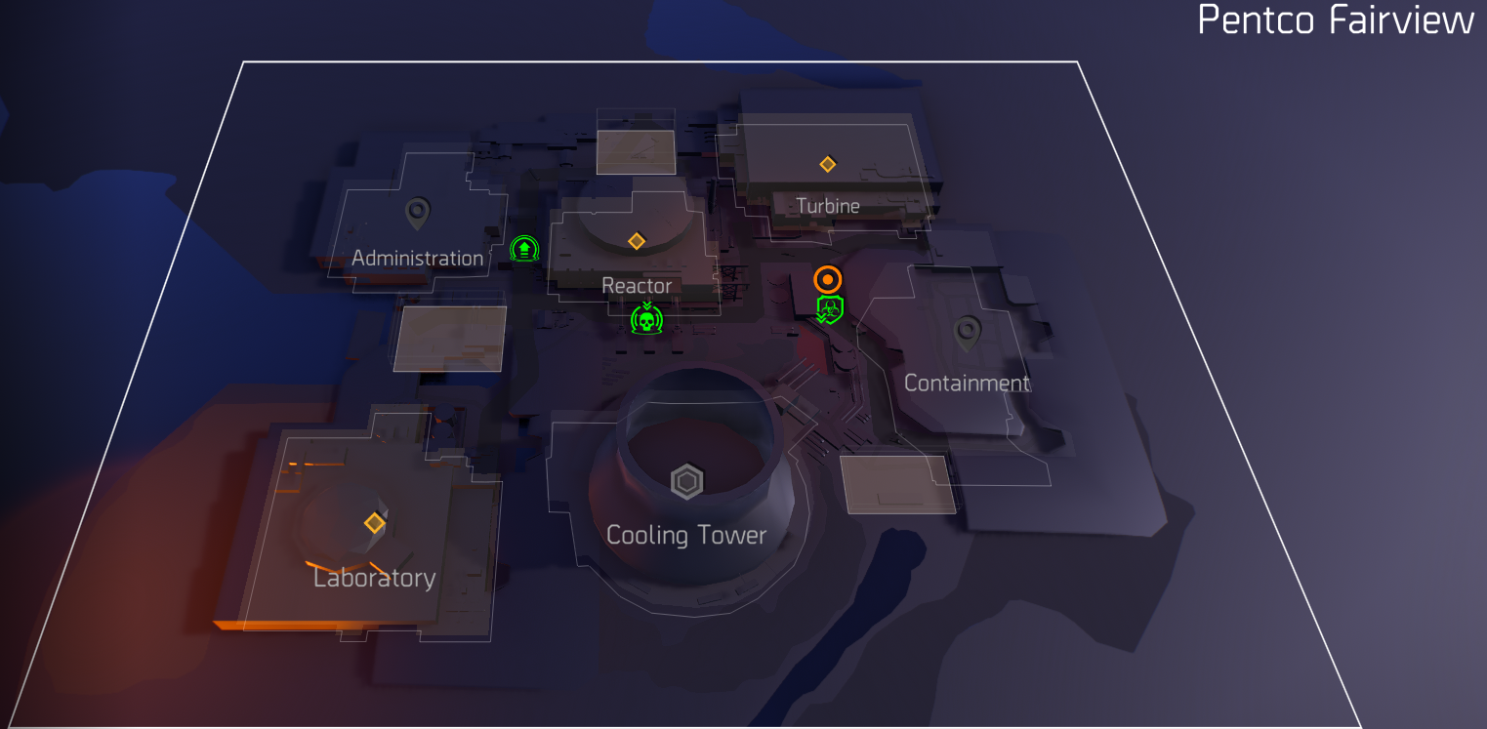

Countermeasures
Each countdown run 3 countermeasures will be assigned randomly for that run, these are first debuffs until an agent interacts with their consoles, and flips it to a buff. These are the big yellow containers that the hunters guard that have an interactable console on them.
Some are quite powerful and can make a run trivial, some are useless.

Both the Teams should go toggle the countermeasures first and defeat the initial 4 hunters before going into any encounters.
  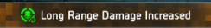  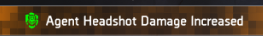          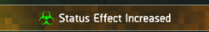  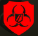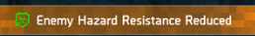  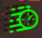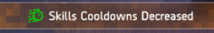    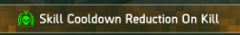  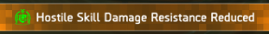 | - The strongest buff, very overpowered,  Needs players to close the range.  - Strong buff, long range not always do-able, but will help on bigger zones.  - Strong buff, increases headshot damage.  - Medium buff, improves reload speed.  - Medium buff, gives CHC.  - Ok buff, Armour regen.  - Unimportant buff, Increases explosive dmg.  - Important Debuff, When red disables Status effects, when green increases duration.  - Increases duration of status effect on enemies.  - Unimportant buff, Skill cooldown faster.  - Unimportant buff, Skills do more damage.  - Unimportant buff, Skill cooldown reduction on kills, similar to scavenged skills.  - Unimportant buff, Enemies take more damage from skills.

Hunters
On challenging and heroic there are four hunters guarding the countermeasure stations, they are like most hunters elite enemies and not nameds.

They have the capabilities of hunters to jammer pulse, and to hack skills, they don't have their own skills like summit hunters, but will hack any skill that is deployable (hives, turrets, traps etc. ) or have a presence in the game world (firefly, seekers, drones etc.).

Skills like sticky, chem and shields cannot be hacked and the only skills that are ok to use in general against them. Damaging skills like turrets and drones should never be used against them, healing or buffing skills can be used if you know what you are doing, and not letting them become hacked and be used against your team.

When engaging them, it is important to try to position yourself in a way that you can have a clear firing path to them, and also try to leave space for others to do the same, try to not move around too much once you have your position.
And avoid using your shield if you are not being fired upon, and even if you do use a shield, try to do so from the sides to not block your allies.

Encounters
Slower objective, has many waves, good for proficiency, mediocre for speed.

Medium speed objective if done well, requires hack of laptops and then destruction of servers, can be done in a short time.

Fastest objective, requires destruction of servers and then the destruction of warhounds, can be done in seconds if played correctly.

Fast objective if done right, required capture of shd crates, this objective is the only one where having multiple people in the objective makes it go faster, if done right can be done in seconds.

Slowest objective, requires protecting the vip, vip can be downed and revived, but can also die if not done in time, good for proficiency, bad for speed, generally avoided.

Main Encounters
Each run, one of the zones will be the main objective, each main encounter is a set order of objectives that
Need to be completed.
There is no variance to the order or locations of objectives within each main, meaning that you can learn the order to do it more quickly.

Some minor tips per main encounter :
Admin : Only one person is needed per capture point, if you start a capture zone then stay in the capture zone, if someone is already set up for a zone, find another and stand ready for when it can be started.
Reactor : The order is set, learn it and you can set up at locations to be ready to hit the next objective quickly.
Turbine : The order is set so try to learn it and be at the ready at objectives, once the first objective is done, there is a ‘the floor is lava’ mechanic, whenever you hear the charge up sound, you need to not be on the main floor.
Lab : Quickly get the valves to start, and then the other order of consoles is set, so try to memorize it, and using the compass can help you do that.
Cooling : Quickly start the valves when they pop up. To make it easier to shoot the pipe covers, get higher up, even standing up on some boxes will let you shoot far ones that are normally obscured
Containment : Set order once again, try to be at the ready for objectives as they pop up.

Crates
Every zone that is an encounter will have an active small black crate with loot. This will be three random items, sometimes a targeted 4th item, and always 1 SHD Calibration.
The main encounter will have a large orange crate that will be available after completing the main objective, this will contain 6-8 items, sometimes an extra targeted item, and always 3 SHD Calibration.

There are three fixed positions for the small crate in each zone, at random one will be the one that is active and available to be looted, this one will look closed, the other two will look opened, so you can spot it from a distance.
For the positions, consult this map guide made by u/ParsleyShogun on Reddit, as it shows all the locations for both the small black boxes and the large orange boxes.
https://www.reddit.com/r/thedivision/comments/uv21qa/countdown_map_to_search_supply_chests/
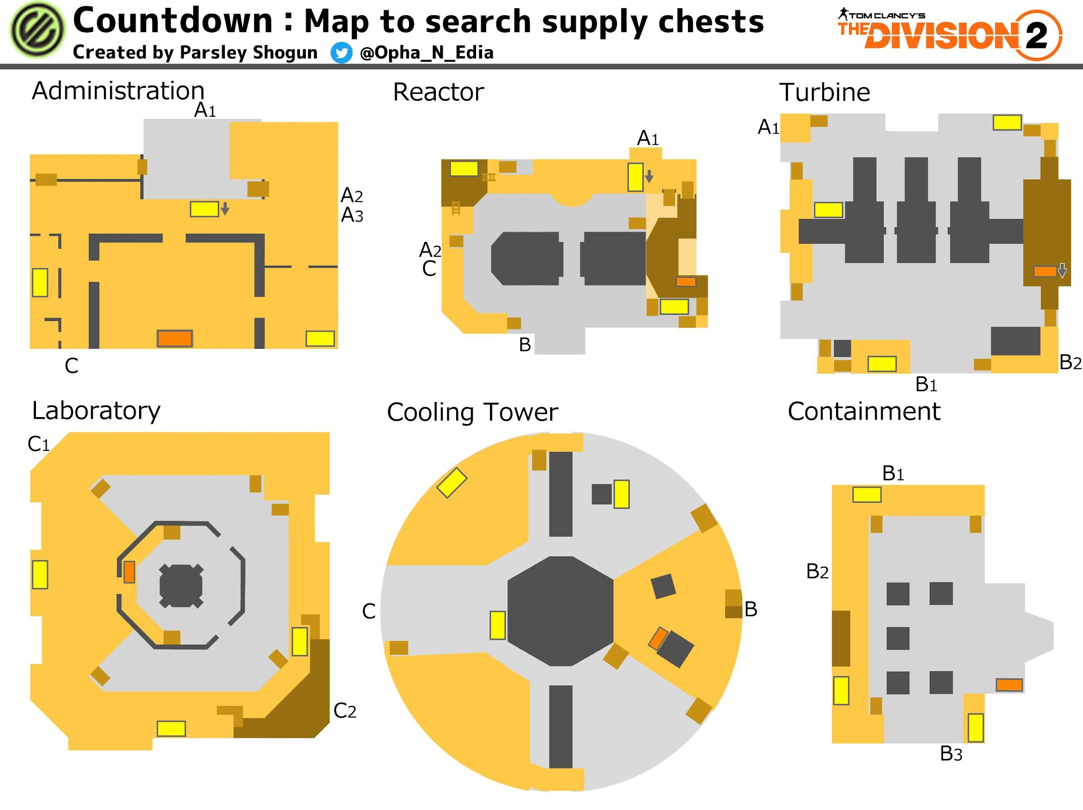
This is one of the better sources for SHD Calibrations, so be sure to check for the box in every zone you are in, and be sure to get the large orange box as well after completing the main objective before extracting.

Extraction
Once the main encounter is completed, extraction and its 4 minutes timer will start.
During extractions, if you die completely, so not just downed but completely die, then you cannot be revived or respawn, and have to leave the countdown.

Because of that it is important to play it safe, as well as keeping an eye on your weakened state debuff if you do get downed, as if you get downed twice while the weakened state icon is on your buffbar, you will die.

During extraction, you will face 4 hunters in and near the extraction zone, so once again damage based skills should not be used, healing and buff skills can be used as long as you place them well, so that they cannot help the enemy if hacked.

With the hunters there will be a sizable force of black tusk, it is important to deal with them well, making sure to kill things like medics and healing boxes quickly, and watching out for drones and airburst grenades.

Once the zone has been cleared, reinforcement black tusk will arrive from choppers, it is the general play to farm these choppers, and that means that it is best to wait with calling in the extraction until the last few seconds. Usually around 5 seconds.
It is considered bad form to instantly call extraction in, as those choppers are a decent and easy way to farm a few more items.

Rewards
Countdown is one of the best places to farm gear or weapons, as a lot of drops happen, this is both because there are a lot of enemies, and also because they are mostly elites.
With each zone you will have at least 1 but likely several named enemies that will drop 1 loot and 1 targeted guaranteed. And also the previously mentioned crates giving even more items.
Also the hunters during extraction will drop two random named items, these items are not based on targeted loot and are random.

Together with that, you will earn Countdown Requisition, usually called countdown currency or countdown coins, that you can spend at a countdown vendor, the one at the white house is located in the shared space, it is a laptop past the GE vendor.
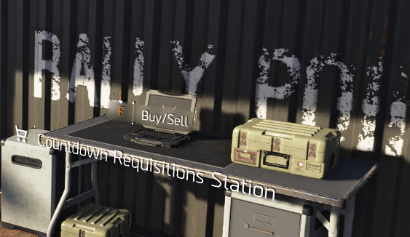
There is also one at NY in haven past the tinkering station.

Of note, the first 2 items are shared with Cassie, if you need either of those items, it is recommended to just get them when she is available as you can do so for normal credits. The third item is unique to the countdown shop, and can be a dz/pvp item and regularly is. Getting a DZ named item can be worth buying if you need that item, either to use or for proficiency.

Mostly your Currency is best spent on exotic caches and named caches.
Exotics caches for getting most/all exotics and for exotic components
Named caches for getting dz/pvp named items for proficiency and use.

The amounts earned are based on difficulty, and mostly the amount of hunter dogtags picked up, generally if you pick up all 8 hunter loot piles, and do 2 minor and one main encounter and successfully extract,
Then on challenging you will earn 158 coins and on heroic you will earn 208 coins.
For reference, doing the third optional minor encounter will only increase those amounts by 2 to 160 and 210, those being the maximum earnable per run, but also obviously not worth the extra time.

Extraction is also important, if you die or wipe or in other ways fail to extract, you will only receive half these amounts, as extraction doubles the base amount of the earlier stated values.

Commendations
- Countdown Cool – awarded for fixing the Cooling Tower’s cooling system in under 5 minutes from the start of the objective. Easily done by doing the encounter quickly.
- Countdown Shocker – awarded for neutralizing 24 shocked hostiles. Easily done by running elmo.
- Countdown Big Spender – awarded for spending 1000 Countdown Requisition Tokens. This will take a few runs, but will get completed easily, this is 6.3 runs of challenging countdowns worth 158 each.
- Countdown Counter – awarded for deactivating every type of countermeasure. This is the hardest one, you will need to be personally the agent disabling the countermeasure, it is not shared. Can be done by going into solo normal difficulty countdown, but also can be done over time by just rushing the consoles quickly while running challenging/heroic.
- Countdown Supply – awarded for resupplying your teammates 20 times by sharing items from your inventory. Easily done by picking up random items you don't need and sharing them at extraction, if other players deconstruct the items, it will still count, but generally best done by sharing your nameds as those can benefit newer players and their proficiency.
General Tips

- Overall the general difficulty to go with is challenging, heroic does require several people to be geared and know what they are doing to be successful, making heroic only worth it if you can get consistent completions.
- Hunters abilities to hack skills, makes it dangerous to use any damaging skills, and basically not worth even attempting to do so, with healing and boosting skills it depends on positioning and what skills they are, a healing drone will be hacked and made to heal them, a healing hive should be deployed far enough away that even if hacked it can not heal them.
- The majority of enemies are elites, with just only a few being veterans or reds. Meaning that protection from elite mods and builds can work decently.
- Overall the better rewards to get are named item caches and exotic caches, starting out named item caches will be your main source of dz items to have most of them so you can proficient them, later on exotic components become the main tool to expertise grade items up and thus they become very valuable. The only other items worth anything are if the third item is a dz item, or legacy caches if you need a piece of system corruption.
- Once you know what you are doing, communicating can be very useful, just typing out the encounters to go for into the chat for instance, can be a easy way to make sure everybody lemmings to the right objectives, and telling people to not rush it during extraction and wait for the team to catch up, can also save agents and/or frustration.
- Always stick together as a big blob, this means that even if you disagree with the team, for instance if most of the team runs into a vip encounter, then it is better for everyone to make the wrong choice together, over splitting up the team and taking longer.
- Sticking together is extra important for extraction, bunching up and going in all together will lead to success allot more consistently than when one or two people rush in by themselves, even if they manage to not get themselves killed, they will scatter the hunters and let the black tusk get setup with their healing boxes and such.
- Pay attention to the objectives and timers, it is easy to just become a headless chicken and just run around and shoot, but you also need to keep an eye out on the time, while not often an issue, it can become one if no one pays attention to the objectives. Furthermore pay attention to what the objective is, if it is a zone to capture, then once you start it, stay in the zone to actually capture it, leaving it can be double bad, as someone else may have gone for it, but they saw you go for it, so they went to other objectives
- It should always be your goal to also get as many of the crates as you can, also getting them early so others of your team see them as well, even if they don't know about the crates they will still just go for the loot. As it is one of the better sources for SHD calibrations, while it is only an average of 6 per run, it adds up a lot over time.

Links to my other guides, the Build Collection, DMG/DPS Calculators and many other things:

https://docs.google.com/document/d/15mg-_sjowh5_8bUp2VIBqnDxCDqz-xJOISl0DlG3RDU

